#### Pay with PayPal use case

**Figure 2‑8- Pay with Paypal use case diagram**

|  |  |  |  |  |
| --- | --- | --- | --- | --- |
| **USE CASE-UC004 SPECIFICATION** | | | | |
| **Use-case No.** | UC004 | **Use-case Version** | | V0.1 |
| **Use-case Name** | Pay with Paypal | | | |
| **Author** | Nguyen Luong Hai | | | |
| **Date** | 31/01/2013 | **Priority** | High | |
| **Actor:**  User  **Summary:**  User can pay for reservation with paypal  **Goal:**  Informs user of the amount that must be paid and guides user through the payment process  **Triggers:**  User want to pay for a reservation  (User clicks “Thanh toán” button in Provide booker’s details screen)  **Pre-conditions:**  User is in page “Fill booker info”  The page is fully loaded.  If user is customer, login with “Customer” role.  **Post-conditions:**  Success:   * Process payment successfully * Generate and display reservation code for user * Complete reservation process   Failure: System displays error message. Content of error message will be specified in Exception section.  **Main Success Scenario:**   |  |  | | --- | --- | | Actor Actions | System Response | | 1. User choose a payment method    3. User clicks on “Thanh toán” button [Alternative 1]    5. Complete payment process in paypal site[Alternative 2] | 2. Display the transaction fee and total amount in VND and USD.    4. Direct user to paypal site. Display payment details   * Ticket Price [Price: number, label] * Ticket Amount [Quantity: number, label] * Transaction fee [Fee: number, label]     6. Redirect to bus reservation site. Show message “Quy trình đặt vé hoàn tất” and reservation details. [Exception 1][Exception 2]   * Booker’s name [Người đặt: string, label] * Reservation code [Mã đặt vé: string, label] * Phone number [Mã đặt vé: string, label] * Email [Email: string, label] * Departure date [Ngày giờ khởi hành: string, label] * Status [Trạng thái: string, label] * Ticket’s departure station [Từ: string, label] * Ticket’s departure time [Ngày đi: string, label] * Ticket’s arrival station [Đến: string, label] * Ticket’s arrival time [Ngày đến: string, label] * Ticket’s seat numbers [Ghế: string, label] * Ticket’s bus type [Loại xe: string, label] |   **Alternative Scenario:**   | Ator Actions | System Response | | --- | --- | | [Alternative 2]  1. User choose another payment method    [Alternative 2]  1. User cancel payment process and return to bus reservation site | 2. Update the transaction fee and total amount in VND and USD.    2. Show message “Thông tin đặt vé của quý khách đã được huỷ” |   **Exceptions:**   |  |  | | --- | --- | |  |  | | Actor Actions | System Response | | [Exception 1]  1. User takes longer than 15 minutes to complete payment process on paypal site.  [Exception 2]  1. Error in requesting payment information or executing payment with PayPal site | 2. Show message “Vì đã quá 15 phút, thông tin đặt vé của quý khách đã bị huỷ”.  2. Show message “Quá trình thanh toán bằng Paypal đã xảy ra lỗi. Xin quý khách vui lòng thử lại hoặc dùng tài khoản khác.” |   **Relationships:**  Login, Provide booker’s details  **Business Rules:**  Payment process must be completed within 15 minutes. | | | | |

**Table** Error! Use the Home tab to apply 0 to the text that you want to appear here.**‑6: Pay with Paypal Use Case Specification**

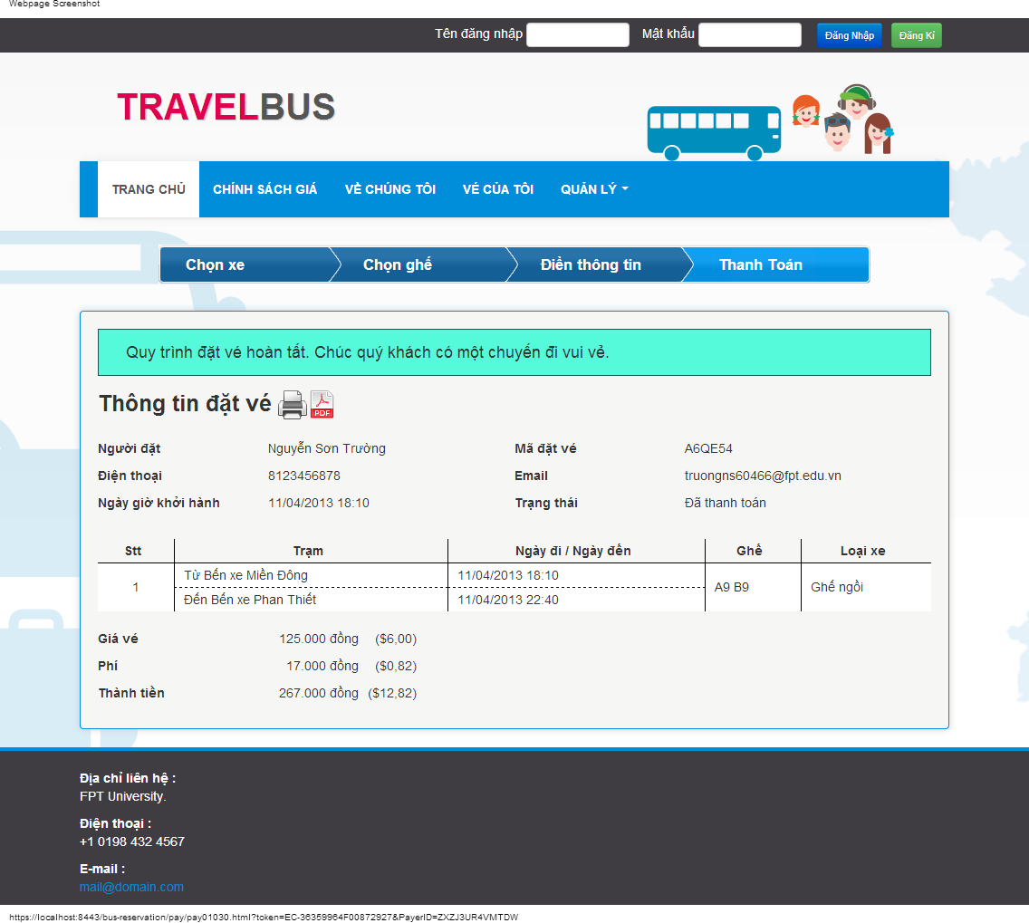**Figure 2‑9- Review reservation details screen**

|  |  |  |
| --- | --- | --- |
| **No.** | **Name** | **Description** |
| **1** | Booker – read-only text (Người đặt) | Display the name of the booker |
| **2** | Reservation code – read-only text (Mã đặt vé) | Display the unique code representing the reservation |
| **3** | Phone number – read-only text (Điện thoại) | Display the phone number to contact the booker |
| **4** | Email – read-only text (Email) | Display the email address to contact the booker |
| **5** | Departure Date – read-only text (Ngày giờ khởi hành) | Display the departure date and time of the first journey |
| **6** | Status – read-only text (Trạng thái) | Display the status of the reservation |
| **7** | Station – read-only text (Trạm) | Display the departure and arrival stations of the journey |
| **8** | Departure date/Arrival date – read-only text (Ngày đi / Ngày đến) | Display the departure and arrival time of the journey |
| **9** | Seat numbers – read-only text (Số ghế) | Display the booked seat numbers in the journey |
| **10** | Ticket price – read-only text (Giá vé) | Display the price of each ticket |
| **11** | Fee – read-only text (Phí) | Display the fee for online booking |
| **12** | Total amount – read-only text (Tổng cộng) | Display the total amount of the reservation |
| **12** | Print – button | Print the reservation details |
| **13** | Print to pdf – button | Print the reservation details to a pdf file |

**Table** Error! Use the Home tab to apply 0 to the text that you want to appear here.**‑7: Review reservation details screen’s Controls**

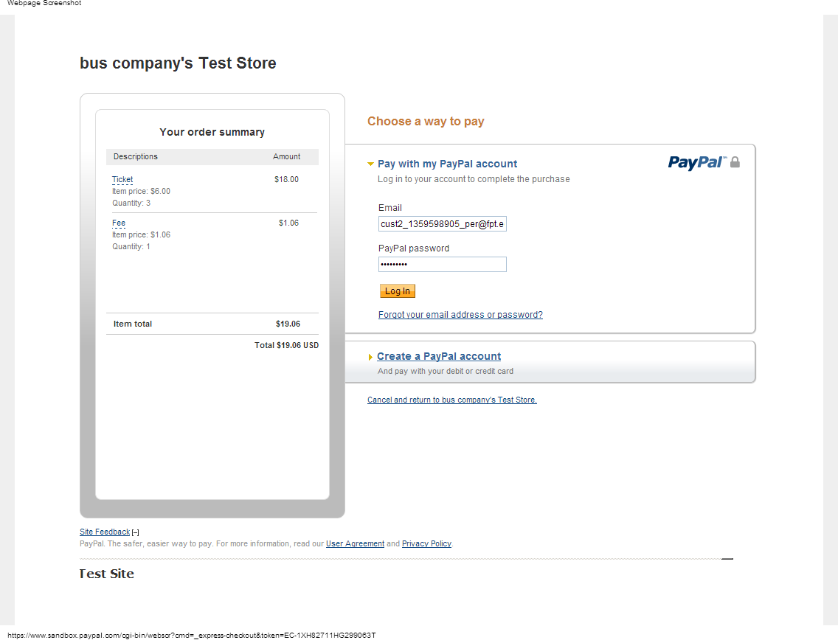**Figure 2‑10- Payment details screen**

|  |  |  |
| --- | --- | --- |
| **No.** | **Name** | **Description** |
| **1** | Ticket price - Read-only field (Item price) | Display the price of ticket |
| **2** | Quantity (Quantity) - Read-only field | Display the quantity of tickets |
| **3** | Fee (Fee) – Read-only field | Display fee for using online booking |
| **4** | Total amount (Total amount) - Read-only field | Display total amount that must be paid |

**Table** Error! Use the Home tab to apply 0 to the text that you want to appear here.**‑8: Paypal site screen’s Controls**

#### D:\Documents\Study\B\usecase\View Reservation List.jpg View Reservation List use case

**Figure 2‑11- View Reservation List use case diagram**

|  |  |  |  |  |
| --- | --- | --- | --- | --- |
| **USE CASE-UC005 SPECIFICATION** | | | | |
| **Use-case No.** | UC005 | **Use-case Version** | | v0.1 |
| **Use-case Name** | View Reservation List | | | |
| **Author** | Nguyen Luong Hai | | | |
| **Date** | 31/01/2013 | **Priority** | High | |
| **Actor:**  User(Customer)  **Summary:**  User views list of past reservations.  **Goal:**  Show all past reservations made by the user  **Triggers:**  User click “Thông tin đặt vé” link in page header  **Pre-conditions:**  The page is fully loaded.  User logins with “Customer” role  **Post-conditions:**  Success: The list of reservations are listed  Failure: N/A  **Main Success Scenario:**   |  |  | | --- | --- | | Actor Actions | System Response | | 1. User click “Vé của tôi” link | 2. Display the list of reservations made by user[Alternative 1]   * Number [Stt: number, label] * Trip [Chặng: string, label] * Book time [Ngày đặt: string, label] * Departure date [Ngày giờ khởi hành: string, label] * Details [Chi tiết: string, link] * Cancel [Huỷ: string, link] [Alternative 2] [Alternative 3] [Alternative 4] |   **Alternative Scenario:**   |  |  | | --- | --- | | Actor Actions | System Response | | [Alternative 1]  1. User hasn’t made any reservation  [Alternative 2]  1. Departure date is in the past  [Alternative 3]  1. Reservation has been cancelled  [Alternate 4]  1. Reservation is locked | 2. Display message “Quý khách chưa đặt vé lần nào”    2. Display Departed [Đã đi: string, label]    2. Display Cancelled [Đã huỷ: string, label]  2. Display Pending [Chờ xuất phát: string, labelư |   **Exceptions:**   |  |  | | --- | --- | | Actor Actions | System Response | | N/A | |   **Relationships:**  Login  **Business Rules:**  A reservation is invalidated if it is not paid within 15 minutes.  A reservation is locked 5 days before departure date. Locked reservations can’t be cancelled. | | | | |

**Table** Error! Use the Home tab to apply 0 to the text that you want to appear here.**‑9: View Reservation List Use Case Specification**

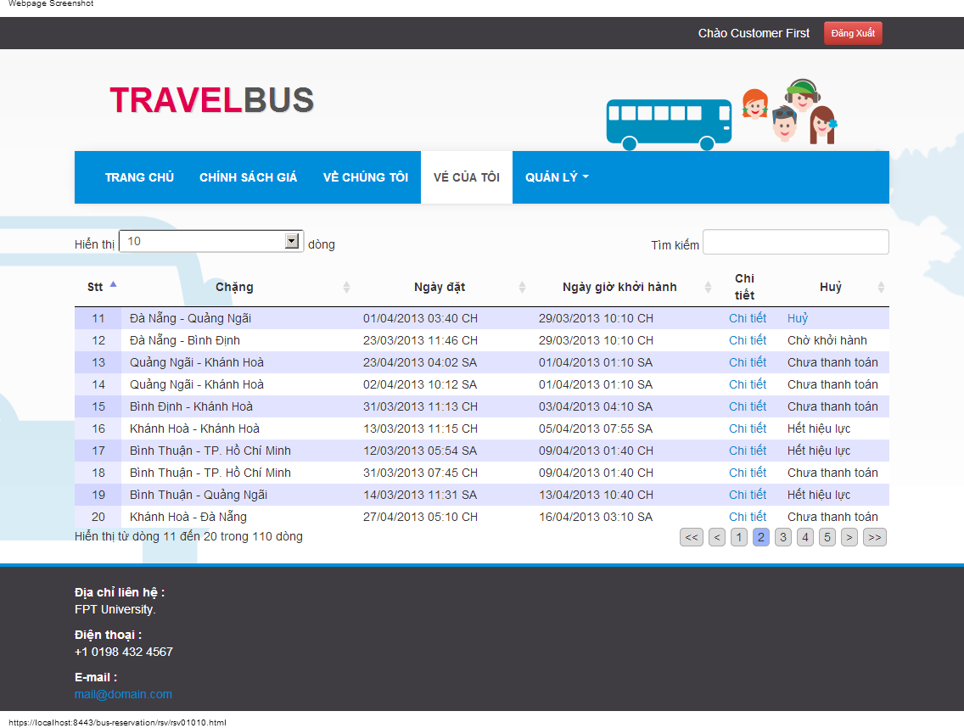**Figure 2‑12- Reservation List screen**

|  |  |  |
| --- | --- | --- |
| **No.** | **Name** | **Description** |
| **1** | Number - Read-only field (Stt) | Display index number of reservation |
| **2** | Trip - Read-only field (Chặng) | Display the starting point and destination of the trip |
| **3** | Book Date – read-only field (Ngày đặt) | Display the book time of the reservation |
| **3** | Departure Date - Read-only field (Ngày giờ khởi hành) | Display the departure date and time of the trip |
| **4** | Details - Link (Chi tiết) | Display reservation details |
| **5** | Cancel - Link (Hủy) | Cancel reservation |

**Table** Error! Use the Home tab to apply 0 to the text that you want to appear here.**‑10: Reservation List screen’s Controls**

* + - 1. View reservation details use case



**Figure 2‑13- View reservation details use case diagram**

|  |  |  |  |
| --- | --- | --- | --- |
| **USE CASE-UC006 SPECIFICATION** | | | |
| **Use-case No.** | UC006 | **Use-case Version** | v0.1 |
| **Use-case Name** | View reservation details | | |
| **Author** | Nguyen Luong Hai | | |
| **Date** | 31/01/2013 | **Priority** | High |
| **Actor:**  User  **Summary:**  User views detailed information of a reservation  **Goal:**  Show user necessary information about the reservation  **Triggers**  User wants to view reservation details.  (Customer click “Chi tiết” in Reservation List screen, or user input reservation code in Search Reservation)  **Pre-conditions:**  The page is fully loaded.  **Post Conditions:**  Success:   * Displays reservation details   Failure: System displays error message. Content of error message will be specified in Exception section.  **Main Success Scenario:**   |  |  | | --- | --- | | Actor Actions | System Response | | 1. Click “Chi tiết” in Reservation List screen  Or enter reservation code and click “Hiển thị” button in the Search Reservation screeen | 2. Display reservation details[Exception 1] [Exception 2] [Exception 3] [Exception 4]   * Booker’s name [Người đặt: string, label] * Reservation code [Mã đặt vé: string, label] * Phone number [Mã đặt vé: string, label] * Email [Email: string, label] * Departure date [Ngày giờ khởi hành: string, label] * Status [Trạng thái: string, label] * Ticket’s departure station [Từ: string, label] * Ticket’s departure time [Ngày đi: string, label] * Ticket’s arrival station [Đến: string, label] * Ticket’s arrival time [Ngày đến: string, label] * Ticket’s seat numbers [Ghế: string, label] * Ticket’s bus type [Loại xe: string, label]   Display button to cancel reservation [Alternative 1] [Alternative 2] |   **Alternative Scenario:**   |  |  |  | | --- | --- | --- | | Actor Actions | System Response | | | [Alternative 1]  1. Reservation is locked, or one of the trip has departed  [Alternative 2]  1. The reservation was cancelled | 2. Does not display cancel button  2. Does not display cancel button  Display refunded amount |   **Exceptions:**   |  |  | | --- | --- | | Actor Actions | System Response | | [Exception 1]  1. Reservation code and email does not match any reservation  [Exception 2]  1. Reservation was made by a registered user, but user has not logged in    [Exception 3]  1. User has logged in, but reservation was made by a different registered user    [Exception 4]  1. User has not entered a reservation code, or the reservation code is a string of 6 alpha-numeric characters | 2. Display message “Không tìm thấy thông tin đặt vé. Xin vui lòng kiểm lại mã đặt vé.”    2. Display message “Quý khách cần đăng nhập để xem thông tin đặt vé này.”    2. Display message “Quý khách không có quyền truy cập thông tin đặt vé này.”    2. Display message “Xin vui lòng nhập mã đặt vé hợp lệ.” |   **Relationships:**  Login, Create Reservation and View Reservation List.  **Business Rules:**  For reservations made by registered users, only the booker can access the reservation | | | |

**Table** Error! Use the Home tab to apply 0 to the text that you want to appear here.**‑11: View Reservation Details Use Case Specification**

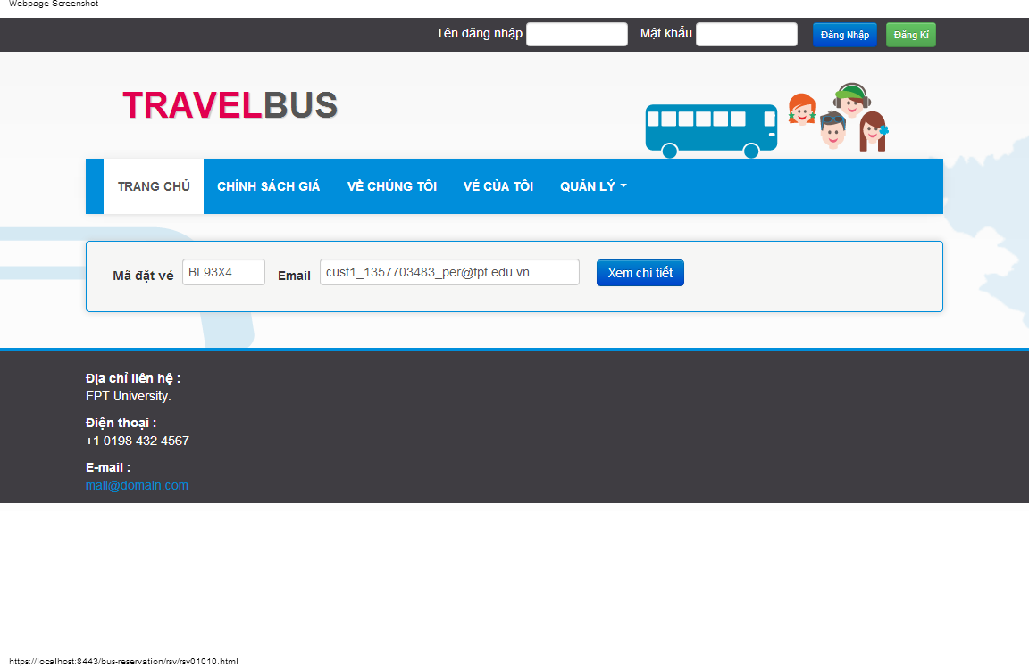**Figure 2‑14- Search Reservation screen**

|  |  |  |
| --- | --- | --- |
| **No.** | **Name** | **Description** |
| **1** | Reservation code - Textbox (Mã đặt vé) | Get code of the reservation to be viewed |
| **2** | Email – Textbox (Email) | Get the email of the booker |
| **2** | Display - button (Xem chi tiết) | Display reservation details |

**Table** Error! Use the Home tab to apply 0 to the text that you want to appear here.**‑12: Search Reservation screen’s controls**

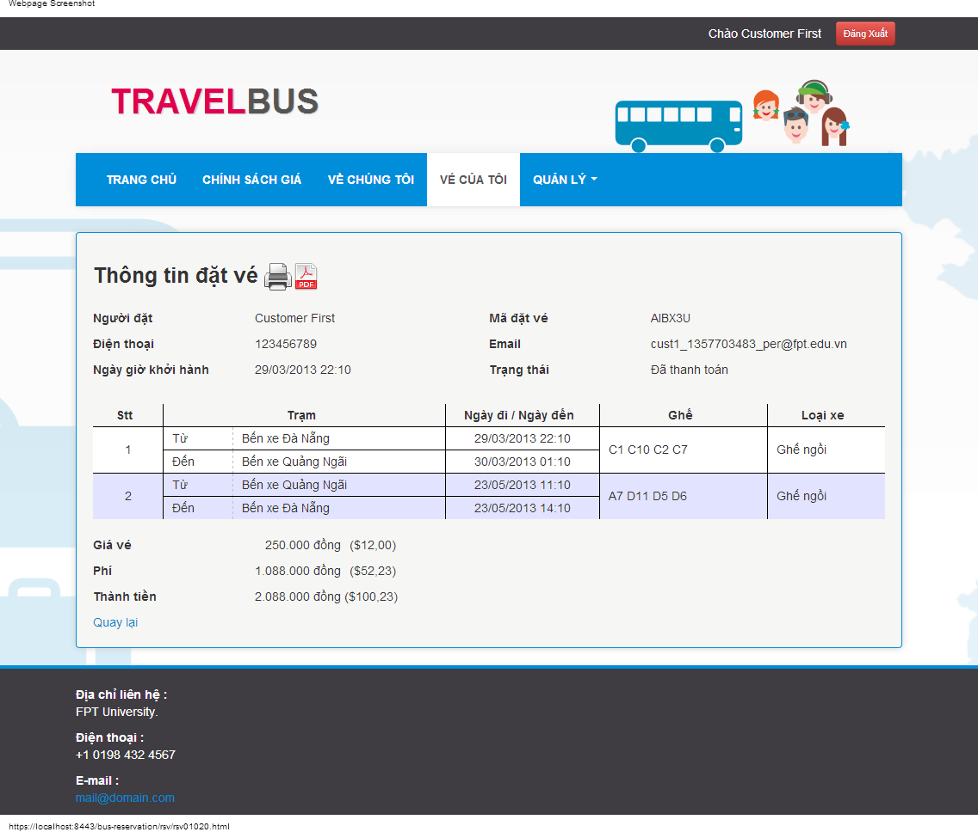**Figure 2‑15- Reservation Details screen**

|  |  |  |
| --- | --- | --- |
| **No.** | **Name** | **Description** |
| **1** | Booker – read-only text (Người đặt) | Display the name of the booker |
| **2** | Reservation code – read-only text (Mã đặt vé) | Display the unique code representing the reservation |
| **3** | Phone number – read-only text (Điện thoại) | Display the phone number to contact the booker |
| **4** | Email – read-only text (Email) | Display the email address to contact the booker |
| **5** | Departure Date – read-only text (Ngày giờ khởi hành) | Display the departure date and time of the first journey |
| **6** | Status – read-only text (Trạng thái) | Display the status of the reservation |
| **7** | Station – read-only text (Trạm) | Display the departure and arrival stations of the journey |
| **8** | Departure date/Arrival date – read-only text (Ngày đi / Ngày đến) | Display the departure and arrival time of the journey |
| **9** | Seat numbers – read-only text (Số ghế) | Display the booked seat numbers in the journey |
| **10** | Ticket price – read-only text (Giá vé) | Display the price of each ticket |
| **11** | Fee – read-only text (Phí) | Display the fee for online booking |
| **12** | Total amount – read-only text (Tổng cộng) | Display the total amount of the reservation |
| **13** | Back – link (Quay lại) | Return to last screen |

**Table** Error! Use the Home tab to apply 0 to the text that you want to appear here.**‑13: Reservation Details screen’s Control**

#### Cancel reservation use case



**Figure 2‑16- Cancel Reservation use case diagram**

|  |  |  |  |  |
| --- | --- | --- | --- | --- |
| **USE CASE-UC007 SPECIFICATION** | | | | |
| **Use-case No.** | UC007 | **Use-case Version** | | v0.1 |
| **Use-case Name** | Cancel Reservation | | | |
| **Author** | Nguyen Luong Hai | | | |
| **Date** | 31/01/2013 | **Priority** | Medium | |
| **Actor:**  User  **Summary:**  User cancel reservation.  **Goal:**  Guide user through cancel reservation process  **Triggers:**  User want to cancel reservation  (User click “Huỷ” button in Reservation List screen or Reservation Details screen).  **Pre-conditions:**  The page is fully loaded.  **Post-conditions:**  Success: The reservation is cancelled.  Failure: The reservation is not cancelled. System displays error message. Content of error message will be specified in Exception section.  **Main Success Scenario:**   |  |  | | --- | --- | | Actor Actions | System Response | | 1. User click link “Huỷ” [Exception 1] [Exception 2]    3. Click button “Có” [Alternative 1]    5. Click button “Đóng” or click outside the popup | 2. Display confirm popup with refund details   * Refund amount [Số tiền hoàn lại: string, label]   4. Cancel the reservation, display message “Chuyến đi đã được huỷ thành công.” Hide button “Có” and button “Không”, display button “Đóng”  6. Close popup and refresh current page |   **Alternative Scenario:**   |  |  | | --- | --- | | Actor Actions | System Response | | [Alternative 1]  1. Click “Không” button. | 2. Close popup. |   **Exceptions:**   |  |  | | --- | --- | | Actor Actions | System Response | | [Exception 1]  1. Reservation was made by a registered user, but user has not logged in    [Exception 2]  1. User has logged in, but reservation was made by a different registered user | 2. Display message “Quý khách cần đăng nhập để hủy thông tin đặt vé này.”  Return to homepage    2. Display message “Quý khách không có quyền truy cập thông tin đặt vé này.”  Return to homepage |   **Relationships:**  Login, Create Reservation, View Reservation List, View Reservation Details  **Business Rules:**  If the reservation is cancelled more than 10 days before the first trip departure date, 80% of the paid amount will be refunded.  Else, if the reservation is cancelled more than 5 days before the first trip departure date, 30% of the paid amount will be refunded.  The reservation cannot be cancelled otherwise. | | | | |

**Table** Error! Use the Home tab to apply 0 to the text that you want to appear here.**‑14: Cancel Reservation Use Case Specification**

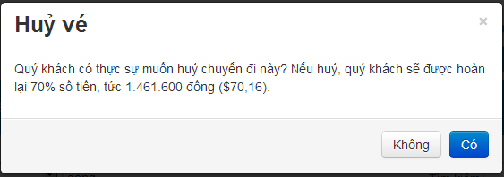**Figure 2‑17- Cancel Reservation Popup**

|  |  |  |
| --- | --- | --- |
| **No.** | **Name** | **Description** |
| **1** | Refund amount – read-only text (Số tiền hoàn lại) | Display the amount to be refunded |
| **2** | Confirm – button (Có) | Cancel the reservation |
| **3** | Back – button (Không) | Cancel the cancel process |

**Table** Error! Use the Home tab to apply 0 to the text that you want to appear here.**‑15: Cancel Reservation popup’s Control**